SAVEETHA INSTITUTE OF MEDICAL AND TECHNICAL SCIENCES
COMPUTER SCIENCE AND ENGINEERING
OCTOBER – 2026

ASSIGNMENT – 1
INTERNET PROGRAMMING

Course Code | CSA43
Course Name | INTERNET PROGRAMMING
Submitted by | BAVANI SRI M(19231405)
Academic Year | 2026–2027

TABLE OF CONTENTS
Section | Description | Page range
Question 1 | Website development, HTML5 document structure, semantic elements and HTML5 features | Pages 3–7
Question 2 | Inline, embedded and external CSS; cascade, specificity and inheritance | Pages 8–12
Question 3 | CSS3 backgrounds, border images, colours, shadows and text effects | Pages 13–17
Question 4 | CSS3 transformations, transitions and keyframe animations | Pages 18–22
Question 5 | Progressive Web Application architecture, service workers, caching and push notifications | Pages 23–27
References | Learning resources and technical documentation | Page 28

Q1 • Website Development and HTML5

1. Introduction to website development
Website development is the process of planning, designing, building, testing and maintaining websites that can be accessed through a web browser. A website may provide information, display products, collect user requests or support complex online services. A successful website combines meaningful content, a clear structure, attractive presentation, reliable functionality and accessibility. The development process begins by understanding the purpose of the website and the people who will use it.
For this case study, consider “Lumina Photography”, a professional photographer who wants a portfolio website. The website must introduce the photographer, display photographs, explain available services, provide package details and allow visitors to contact the photographer. The target users include individuals searching for wedding photography, event coverage, portraits and commercial photography. The design should therefore be visual, responsive, easy to navigate and quick to load.
The development process can be divided into requirement analysis, planning, interface design, content preparation, implementation, testing, deployment and maintenance. During requirement analysis, the developer identifies the audience, required pages, expected actions and technical constraints. Planning defines the site map and navigation. Design determines layout, typography, colours and image placement. Implementation converts the design into HTML, CSS and JavaScript. Testing checks links, forms, accessibility, browser compatibility and responsive behaviour before deployment.
A website is commonly divided into front-end and back-end components. The front end is the part users see and interact with. It is built mainly using HTML for structure, CSS for presentation and JavaScript for behaviour. A back end may process bookings, authenticate users, store messages and communicate with a database. A simple portfolio can be a static website, while a booking platform may require server-side processing. The selected architecture should match the actual requirements rather than adding unnecessary complexity.
The main quality goals for Lumina Photography are usability, accessibility, performance, consistency, security and maintainability. A visitor should be able to reach the gallery or contact details without confusion. Images should have suitable alternative text, pages should work on mobile devices and forms should provide clear validation feedback. Optimised images and clean code improve loading speed. Consistent headings, spacing and colours make the website feel professional.
Key point: Website quality depends on structure, usability, accessibility and testing.

2. HTML5 document structure
HTML5 is the standard markup language used to describe the structure and meaning of web content. An HTML document contains elements represented by tags. Most elements have an opening tag, content and a closing tag. Attributes provide additional information, such as an image source, link destination or language. A browser reads the markup and constructs a document object model (DOM), which can then be styled with CSS and manipulated with JavaScript.
A basic HTML5 document begins with the DOCTYPE declaration. The html element is the root element and commonly includes a lang attribute. The head section contains information about the document, such as character encoding, viewport settings, title and links to stylesheets. The body section contains the content displayed in the browser. The UTF-8 character declaration supports a wide range of characters, while the viewport meta element helps the page adapt to mobile screen widths.
The title element gives the page a meaningful name in the browser tab and is also useful for search results. A meta description can provide a short summary of the page. The link element connects an external CSS file, and script can load JavaScript. Keeping metadata in the head and visible content in the body makes the document organised and easier to maintain. The document should use proper nesting and close elements correctly where required.
For the photography website, the home page can contain a header with the brand name, a navigation area, a main section with an introduction and featured photographs, and a footer with contact information. The document structure should reflect this content hierarchy. Headings should be used in logical order, beginning with the main page heading. A meaningful structure helps browsers, assistive technologies and search engines understand the content.
The following illustration shows the broad organisation of a standard HTML5 page. It is a conceptual diagram rather than a screenshot of a running website.
Key point: Semantic elements describe meaning; CSS and JavaScript provide presentation and behaviour.

3. Semantic elements in HTML5
Semantic HTML elements describe the purpose of the content they contain. Instead of using generic containers for every part of a page, semantic elements identify common page regions. Important elements include header, nav, main, section, article, aside, footer, figure and figcaption. These elements do not automatically create a visual design; CSS controls their appearance. Their main benefit is that they give the document a clearer meaning and improve its organisation.
The header element represents introductory content for a page or section. It may contain a logo, title or introductory information. The nav element groups important navigation links. The main element identifies the dominant content of the page and should normally be used once for the primary page content. A section groups related content under a heading, while article represents a self-contained item that could be understood independently.
In Lumina Photography, the header can contain the logo and site navigation. The main element can contain a welcome section and a gallery section. Each portfolio project can be represented by an article if it has its own title, description and photograph. The figure element can group an image with a figcaption describing the photograph. The aside element may contain related information such as a short photographer biography or availability note. The footer can contain copyright information and contact links.
Semantic elements improve accessibility because assistive technologies can expose landmarks that help users move around a page. They also make source code easier for developers to read. A developer opening the document can quickly identify the navigation, main content and footer without interpreting a large collection of anonymous div elements. Semantic markup can support search-engine understanding, although it does not guarantee a particular search ranking.
Semantic tags must be selected according to meaning, not merely because they produce a desired visual effect. For example, a section should represent a thematic grouping and normally have a heading. A nav element should contain a significant navigation block, not every group of links. A footer may appear at the end of a page or section. Correct use of semantics creates a logical and accessible content structure.
Key point: HTML5 features should be selected according to the needs of users and the website.

4. Important HTML5 features
HTML5 introduced and standardised features that make modern web pages more capable. Native audio and video elements allow media to be embedded without depending on older plug-in technologies. The canvas element provides a drawing surface that can be controlled with JavaScript. SVG can be used for scalable vector graphics. Form improvements include input types such as email, date, number and url, along with attributes such as required, placeholder and pattern.
The audio and video elements support media playback through browser controls. A video element can include width, controls and a source element that identifies the media file and its type. The browser can select a supported format. Captions can be supplied using a track element. Media should be provided with appropriate text alternatives or captions so that users who cannot hear or see the content can still understand it.
HTML5 forms make common input tasks easier. An email input can request an email address and allow browser validation. A required attribute indicates that a field must be completed before submission. The placeholder attribute provides a hint, but it should not replace a visible label. The developer should also validate input on the server because browser-side validation can be bypassed. Clear error messages help users correct mistakes.
Other important capabilities include improved document semantics, local storage, session storage, geolocation through browser APIs and drag-and-drop support. Local storage can preserve small amounts of data in the browser across sessions, while session storage is generally limited to a browsing session. Geolocation requires user permission and should only be requested when it is needed. These capabilities are implemented through web APIs and must be used with attention to privacy and security.
HTML5 is not a programming language; it is a markup standard. JavaScript provides application logic, CSS provides visual presentation and browser APIs provide additional capabilities. A developer should check browser support and provide a graceful alternative when a feature is unavailable. Using native HTML features wherever possible reduces unnecessary code and improves compatibility with assistive technologies.
Key point: Examples should be tested in browsers and adapted to the actual project.

5. Case-study implementation and evaluation
The following example demonstrates a simplified semantic structure for the Lumina Photography home page. The code uses meaningful HTML5 elements and includes a navigation region, main content, a portfolio section and a footer. The image source is a placeholder and should be replaced with an optimised photograph supplied by the photographer.
<!DOCTYPE html>
<html lang="en">
<head>
<meta charset="UTF-8">
<meta name="viewport" content="width=device-width, initial-scale=1.0">
<title>Lumina Photography</title>
</head>
<body>
<header>
<h1>Lumina Photography</h1>
<nav aria-label="Main navigation">
<a href="#about">About</a>
<a href="#portfolio">Portfolio</a>
<a href="#contact">Contact</a>
</nav>
</header>
<main>
<section id="about">
<h2>Stories through the lens</h2>
<p>Professional photography for meaningful moments.</p>
</section>
<section id="portfolio">
<h2>Selected work</h2>
<figure>
<img src="images/wedding.jpg" alt="Bride and groom during an outdoor wedding">
<figcaption>Wedding photography collection</figcaption>
</figure>
</section>
</main>
<footer id="contact">
<p>Email: hello@example.com</p>
</footer>
</body>
</html>
The implementation should be evaluated using a checklist. First, open the page in a browser and confirm that the title appears in the tab. Check that every navigation link moves to the correct section. Confirm that images load and alternative text is meaningful. Resize the browser to a narrow mobile width and ensure that content remains readable. Use keyboard navigation to check that links can be reached and activated without a mouse.
The case study demonstrates that website development is not limited to writing tags. A complete website requires planning, meaningful content, accessibility, responsive presentation and testing. HTML5 provides the structural foundation, while CSS and JavaScript add visual design and interaction. Semantic elements make the document easier to understand and maintain. These practices help Lumina Photography present its work professionally and provide visitors with a useful experience.
Illustrative result: the sample browser preview below represents the type of portfolio landing page that can be created from the semantic structure. The image is generated for this assignment and is not a live website.
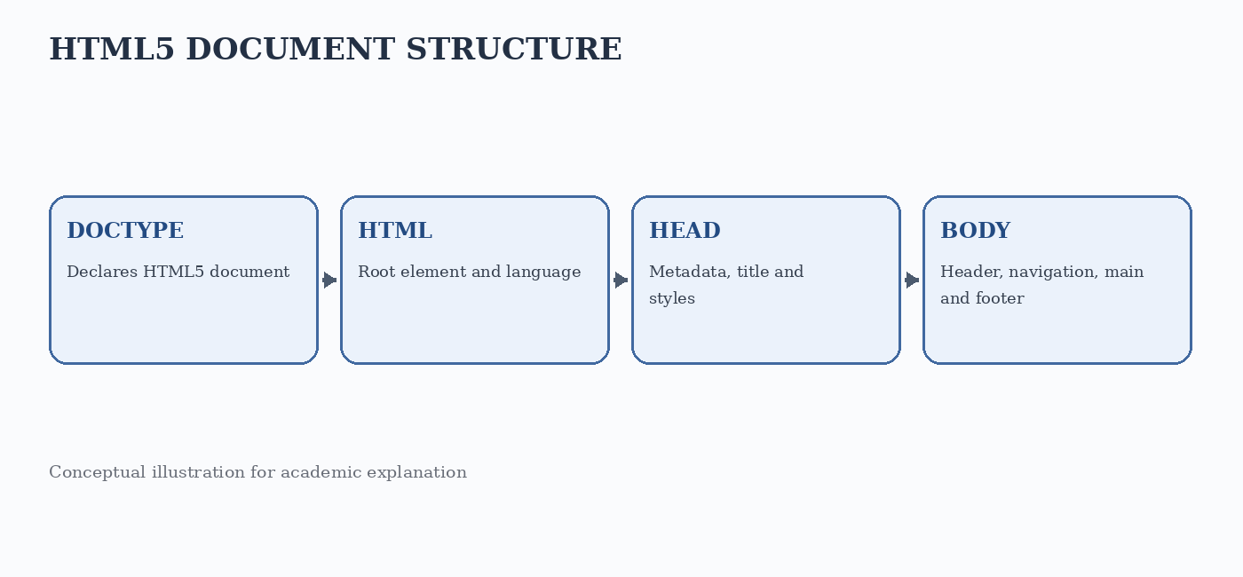
Figure: Illustrative generated visual for the related case study.
Key point: A clear implementation is easier to maintain than unnecessary complexity.

Q2 • CSS Methods and Cascade

1. Introduction to CSS in a photography webpage
CSS stands for Cascading Style Sheets. It is used to control the visual presentation of HTML documents, including colours, fonts, spacing, borders, alignment and responsive layout. Separating structure from presentation makes a website easier to maintain. HTML describes what content means, while CSS describes how that content should look. A professional photographer can use CSS to create a consistent visual identity across the home page, gallery, service information and contact page.
The case study continues with Lumina Photography. The design requires a dark navigation bar, large photographs, readable headings, consistent spacing and a clear contact button. CSS can be written in three common ways: inline CSS, embedded or internal CSS, and external CSS. Each method has a different scope and maintenance impact. Understanding the cascade is important because more than one rule may apply to the same element.
Inline CSS is written inside the style attribute of an HTML element. It is useful for a quick one-off demonstration, but it mixes content and presentation and is difficult to reuse. Embedded CSS is placed in a style element in the document head. It can style one page without creating a separate file. External CSS is stored in a .css file and connected through a link element. It is usually the best choice for a multi-page website because one stylesheet can be reused.
A well-organised project may contain index.html, about.html, gallery.html, contact.html, a css folder and an images folder. The external stylesheet can define shared colours, typography, navigation and button styles. Page-specific classes can handle special layouts. The developer should use meaningful class names such as gallery-grid or contact-form instead of names that describe only temporary appearance.
CSS supports maintainability when rules are grouped logically, repeated values are centralised and selectors are kept reasonably simple. A photographer may later change the brand colour or font size. With an external stylesheet, the developer can update shared rules in one place rather than editing every HTML page separately.
Key point: Website quality depends on structure, usability, accessibility and testing.

2. Inline, embedded and external CSS
Inline CSS applies a declaration directly to one HTML element. For example, a heading can use style="color: navy; text-align: center;". This method has a narrow scope and is quick to test. However, repeating inline styles across many elements creates duplication. Inline declarations can also make later maintenance harder because the presentation is scattered throughout the markup.
Embedded CSS is written inside a style element, commonly in the head section. A rule such as .hero-title { color: #203b63; } can style every element with that class on the current page. Embedded styles are useful for a single standalone page or a small demonstration. They are less convenient when the same design must be shared across several pages because each page may need its own copy of the rules.
External CSS is placed in a separate file, for example styles.css, and linked using <link rel="stylesheet" href="styles.css">. This approach keeps HTML cleaner and encourages reuse. A shared stylesheet can contain global rules for body, header, navigation, headings, links and buttons. The browser can cache the stylesheet, which may reduce repeated downloading when users visit multiple pages.
For the photographer's website, external CSS should be the main method. Inline styles may be reserved for a controlled dynamic value generated by an application, while embedded CSS may be useful in a small prototype. In a production site, consistent styling should be maintained in a shared stylesheet. The choice should be based on reuse, maintainability and the size of the website rather than on a belief that one method is always technically impossible.
The three methods can coexist, but developers should avoid unnecessary conflicts. If the same property is declared in several places, the browser resolves the result using cascade rules. Understanding source order, importance, specificity and inheritance makes it easier to predict the final appearance of an element.
Key point: Semantic elements describe meaning; CSS and JavaScript provide presentation and behaviour.

3. Cascading rules, specificity and inheritance
The cascade is the process by which the browser decides which CSS declaration applies when multiple declarations target the same property on an element. The result depends on factors such as origin, importance, cascade layer, specificity and source order. For ordinary author styles, a more specific selector generally takes precedence over a less specific selector. When declarations have equal priority and specificity, the later declaration usually wins.
Specificity is commonly explained using selector categories. Inline style declarations have a high priority in the author styling context. ID selectors are more specific than class, attribute and pseudo-class selectors. Class selectors are more specific than element selectors. Universal selectors do not add specificity. Specificity is not simply a count of all characters; it is compared in categories. A selector with an ID generally outranks a selector containing several class selectors.
Consider the rules p { color: black; }, .intro { color: darkblue; } and #welcome { color: maroon; }. If a paragraph has both class="intro" and id="welcome", the ID selector has greater specificity and the text becomes maroon, assuming no other higher-priority declaration applies. If two rules use the same selector and importance, the rule appearing later in the stylesheet normally determines the value.
Inheritance means that some CSS properties applied to a parent element are passed to its descendants unless a child has its own value. Text-related properties such as color, font-family and line-height commonly inherit. Properties such as margin, padding, border and width generally do not inherit. Inheritance reduces repetition: setting a base font family on the body can provide a consistent font throughout the page.
The inherit keyword explicitly requests a property value from the parent. The initial keyword resets a property to its initial value, while unset behaves as inherit for naturally inherited properties and as initial for other properties. These keywords can be useful, but they should be applied carefully. A simple stylesheet with a clear base rule is usually easier to understand than one containing many resets and overrides.
Key point: HTML5 features should be selected according to the needs of users and the website.

4. Real-time application and stylesheet example
In a real-time photography portfolio, the navigation bar, gallery cards and booking button should follow a consistent design. The body rule can set the default font and text colour. The header rule can create a dark background. The navigation links can use padding and hover effects. The gallery can use CSS Grid so that photographs rearrange according to available screen width. A button class can be reused for contact and booking actions.
Example external stylesheet:
body {
margin: 0;
font-family: "Times New Roman", serif;
color: #252525;
line-height: 1.6;
}
.site-header {
background: #17243a;
color: white;
padding: 20px 5%;
}
.site-nav a {
color: white;
text-decoration: none;
margin-right: 18px;
}
.site-nav a:hover {
text-decoration: underline;
}
.gallery-grid {
display: grid;
grid-template-columns: repeat(auto-fit, minmax(220px, 1fr));
gap: 18px;
}
Example HTML connection:
<head>
<link rel="stylesheet" href="styles.css">
</head>
<body>
<header class="site-header">
<h1>Lumina Photography</h1>
<nav class="site-nav">
<a href="index.html">Home</a>
<a href="gallery.html">Gallery</a>
</nav>
</header>
</body>
The class names connect the HTML elements to the external CSS rules. The same stylesheet can be linked from every page, giving the website a consistent appearance.
The CSS Grid rule uses auto-fit and minmax to create columns that adapt to the available width. On a wide screen, several photographs may appear in one row. On a narrow screen, the grid automatically reduces the number of columns. This is more flexible than assigning fixed widths to every image. Images should also use max-width: 100% and height: auto to avoid overflowing their containers.
Key point: Examples should be tested in browsers and adapted to the actual project.

5. Comparison, testing and case-study result
Inline, embedded and external CSS are useful in different situations, but external CSS is the most suitable primary method for the multi-page photography website. Inline CSS is limited to a single element and is difficult to reuse. Embedded CSS is convenient for one page but can lead to repeated code. External CSS separates presentation from content, supports shared design rules and improves long-term maintenance.
A practical testing sequence is to load the page with the external stylesheet enabled, temporarily disable the stylesheet to inspect the HTML structure, and then use browser developer tools to examine individual declarations. Test at desktop, tablet and mobile widths. Check that text has sufficient contrast, links are visible, focus indicators are present and hover styles do not provide the only indication of interactivity.
Common mistakes include forgetting to link the stylesheet, using an incorrect file path, misspelling a class name, placing a rule inside an invalid location and assuming that all properties inherit. Another common issue is overusing ID selectors, which makes later overrides difficult. A consistent naming convention and a small set of reusable components reduce these problems.
The sample screenshot below illustrates the expected visual outcome after applying a coordinated stylesheet. It demonstrates a branded header, clear title and organised content cards. It is an illustrative generated screenshot for explanation; it does not represent an actual deployed site.
In conclusion, CSS is essential for turning structured HTML into a polished website. Inline, embedded and external styles each have a purpose, while cascade, specificity and inheritance determine how declarations interact. For Lumina Photography, a shared external stylesheet provides the best balance of consistency, reusability and maintainability. 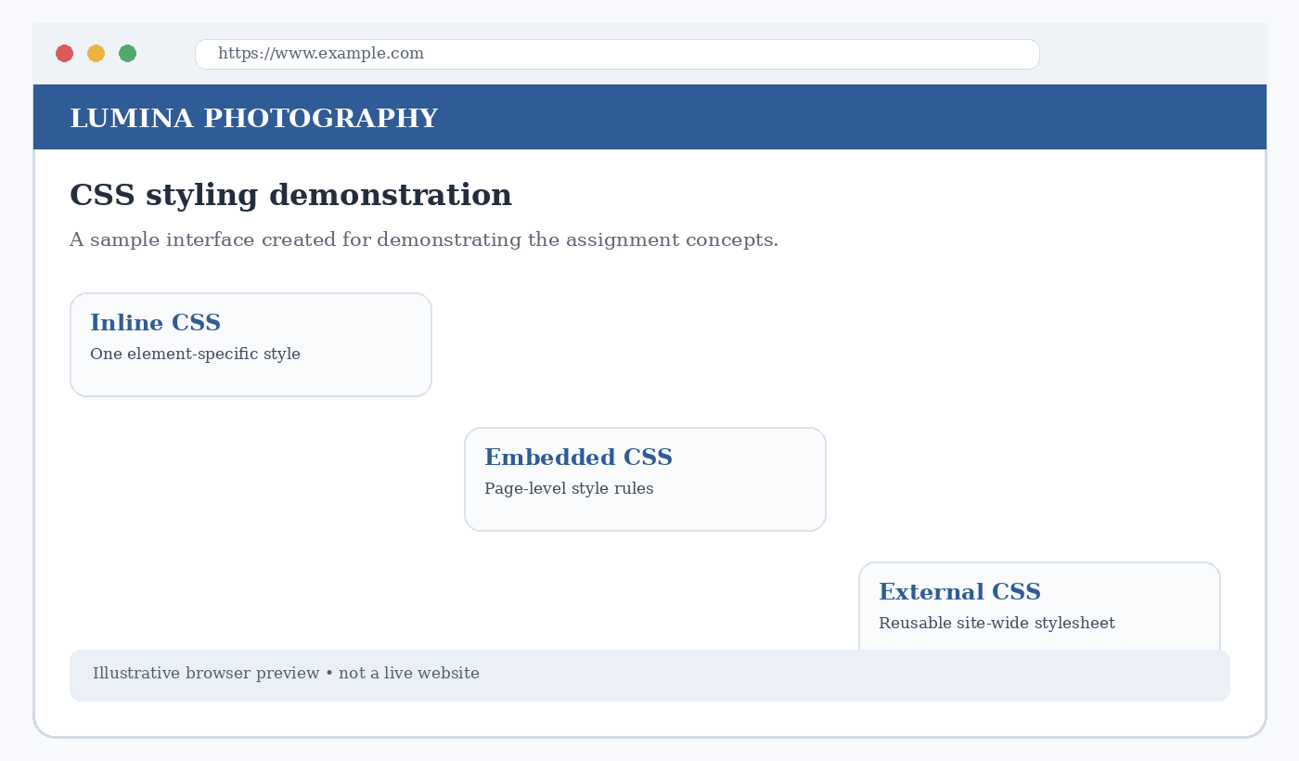
Figure: Illustrative generated visual for the related case study.
Key point: A clear implementation is easier to maintain than unnecessary complexity.
Q3 • CSS3 Visual Design

1. Introduction to modern CSS3 design
CSS3 refers to the evolution of CSS through modular specifications that introduced and expanded visual design capabilities. Modern CSS supports gradients, rounded corners, shadows, multiple backgrounds, border images, flexible layouts, transitions, transformations and animations. These features allow developers to create attractive interfaces without relying on images for every decorative effect. A GoDaddy website template can be used as a reference for common professional design patterns such as a strong hero area, clear call-to-action, content cards and consistent navigation.
For this question, consider a service-business website inspired by the layout conventions commonly seen in website templates. The page contains a top navigation bar, a large hero section, service cards, customer information and a footer. The reference is used to discuss design techniques, not to copy a specific commercial template or its assets. The implementation should use original text, images and styling.
A modern design begins with a visual hierarchy. The most important message should be prominent, secondary information should be grouped logically and calls to action should be easy to find. Colour establishes identity and contrast. Backgrounds provide depth, borders separate content, shadows indicate elevation and text effects help emphasise selected headings. These effects should support readability rather than distract from the information.
CSS3 design should also consider responsiveness and accessibility. A beautiful desktop layout may become difficult to use on a phone if fixed widths are used. Text shadows and background images can reduce contrast if applied carelessly. Motion and decorative effects should be restrained, and users who prefer reduced motion should be considered when animations are added. The page must remain usable when visual effects are unavailable.
The following sections explain backgrounds, border images, colours, shadows and text effects with code examples. The examples use a fictional service website so that each CSS property can be related to a realistic page component.
Key point: Website quality depends on structure, usability, accessibility and testing.

2. Backgrounds and colour techniques
The background property controls the area behind an element. A background can be a solid colour, an image, a gradient or a combination of multiple layers. The background-color property provides a base colour. background-image can load an image or define a gradient. background-size controls image scaling, while background-position determines where the image is placed. background-repeat controls whether an image repeats.
A hero section can use a linear gradient to create a smooth transition between two colours. For example:
.hero {
background: linear-gradient(120deg, #17243a, #456b91);
color: #ffffff;
padding: 90px 8%;
}
The gradient is generated by the browser, so it does not require a separate image file. A background photograph can be layered with a semi-transparent gradient to keep the heading readable.
Example using an image background:
.hero-photo {
background-image:
linear-gradient(rgba(15, 25, 40, .55), rgba(15, 25, 40, .55)),
url("images/studio.jpg");
background-size: cover;
background-position: center;
color: white;
}
The first background layer is painted above the image layer. The dark overlay improves the contrast of white text. The image should be compressed and selected carefully so that it does not make the page unnecessarily slow.
Colour can be specified using named colours, hexadecimal notation, RGB, RGBA, HSL or HSLA values. RGBA includes an alpha channel for transparency. A design system should define a small palette for primary, secondary, background, text and accent colours. Reusing the same values across buttons, headings and links makes the page consistent. Colour should not be the only way to communicate a status; text or icons should also be provided.
A background should not reduce readability. When text is placed over a photograph, use an overlay or a solid content panel. Test the page with different screen sizes and image crops. If the image fails to load, the background colour should still provide a suitable fallback. This improves resilience and ensures that the content remains understandable.
Key point: Semantic elements describe meaning; CSS and JavaScript provide presentation and behaviour.

3. Border images, borders and shadows
CSS borders define the edges of an element. The border property combines width, style and colour. border-radius creates rounded corners and is commonly used for buttons and cards. CSS3 also provides border-image, which allows an image to be sliced and used as an element's border. The border-image-source identifies the image, border-image-slice defines how it is divided, and border-image-repeat controls how the slices are displayed.
Example border image:
.frame {
border: 18px solid transparent;
border-image-source: url("images/decorative-frame.png");
border-image-slice: 30;
border-image-repeat: stretch;
}
The image should be designed with corners and edges that can be sliced cleanly. Border images are useful for decorative frames, but ordinary borders are simpler and more suitable for most interface components. If the border image is unavailable, the transparent border may not provide a visible fallback, so a fallback border colour can be planned.
The box-shadow property adds a shadow around an element's box. Its common values include horizontal offset, vertical offset, blur radius, spread radius and colour. For example, box-shadow: 0 8px 24px rgba(0,0,0,.12); creates a soft shadow below a card. Multiple shadows can be separated by commas. Inset shadows are drawn inside the element and can create a pressed or recessed appearance.
Cards on a service website can use a light border and subtle shadow to separate them from the background. Shadows should be consistent and not too dark. Excessive shadows make a page visually heavy and may reduce the clarity of content. A border can be used together with a shadow, but the combination should remain subtle. The visual hierarchy should be created primarily through spacing, typography and alignment.
Borders and shadows should not be used as the only way to show focus. Keyboard users need a visible focus indicator, and interactive controls should have a clear hover and active state. A decorative shadow can enhance the appearance of a button, but the button must still have an accessible label and a sufficiently large clickable area.
Key point: HTML5 features should be selected according to the needs of users and the website.

4. Text effects and complete CSS example
CSS text effects can improve emphasis and visual identity. The text-shadow property adds a shadow behind characters. It accepts horizontal and vertical offsets, blur radius and colour. The text-transform property changes letter case for display, while letter-spacing controls the space between characters. text-overflow can indicate clipped text, and white-space controls wrapping behaviour. These properties should be used carefully because long headings and all-uppercase text can be difficult to read.
Example:
.hero h1 {
font-size: clamp(2rem, 5vw, 4.5rem);
letter-spacing: .03em;
text-shadow: 0 3px 10px rgba(0,0,0,.35);
}
.service-card {
background: #ffffff;
border: 1px solid #dce3ec;
border-radius: 14px;
box-shadow: 0 8px 24px rgba(20,40,65,.10);
padding: 24px;
}
The clamp function allows the heading size to respond to viewport width while remaining within minimum and maximum values.
A complete component can combine a gradient background, rounded corners, a border and a shadow. The design should be tested with real content because a card that looks balanced with short sample text may become crowded when a longer description is added. Use adequate line height, readable font size and consistent padding. Images should have an appropriate aspect ratio and should not stretch unnaturally.
Example button:
.primary-button {
display: inline-block;
padding: 12px 22px;
border: 0;
border-radius: 7px;
background: #e07b45;
color: #ffffff;
font-weight: bold;
text-decoration: none;
box-shadow: 0 4px 12px rgba(20,30,45,.18);
}
.primary-button:hover {
background: #c96332;
}
The hover state gives feedback, but the default state must remain clearly identifiable as a button or link.
A design inspired by a commercial website template should be treated as a learning reference. Developers should not copy protected logos, photographs or proprietary content without permission. They can study general layout patterns and recreate them with original assets and code. This approach demonstrates CSS knowledge while respecting intellectual property.
Key point: Examples should be tested in browsers and adapted to the actual project.

5. Visual evaluation and design result
The sample generated screenshot shows a fictional template-inspired service website. It demonstrates a prominent brand header, a clear hero title and three content cards. In a real implementation, the cards could describe services, pricing or customer benefits. The background and colour palette create a consistent visual identity, while spacing and alignment make the content easier to scan.
Evaluation should include visual consistency, readability, responsiveness and performance. Check that the colour palette is used consistently. Confirm that text placed over images remains readable. Test the border and shadow effects on both large and small screens. Make sure that the layout does not depend on a fixed width that causes horizontal scrolling. Inspect the page when images are disabled to confirm that important information is still available.
The following checklist can be used during testing:
• Background images have suitable fallbacks and do not obscure text.
• Border images, if used, display correctly at different sizes.
• Text and background colours have sufficient contrast.
• Shadows are subtle and do not hide borders or focus indicators.
• Headings remain readable at narrow viewport widths.
• Decorative effects do not interfere with navigation or content.
Modern CSS3 features help developers create polished web pages with less reliance on image-based decoration. Backgrounds and gradients establish atmosphere, border images create decorative frames, colours establish identity, shadows create depth and text effects emphasise important content. These features are most effective when they are applied consistently and support the purpose of the website.
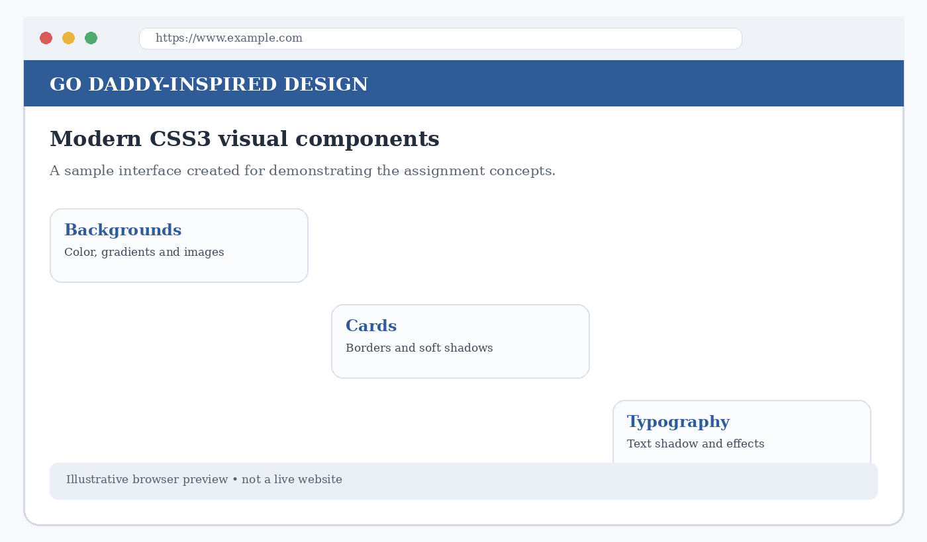
Figure: Illustrative generated visual for the related case study.
Key point: A clear implementation is easier to maintain than unnecessary complexity.
Q4 • CSS3 Transformations and Animation

1. Introduction to contemporary page design
A contemporary web page combines a clean layout, readable typography, responsive structure and carefully selected interactive effects. CSS3 transformations, transitions and animations can make an interface feel more dynamic. A transformation changes the visual position, size, rotation or shape of an element. A transition controls how a property changes over time. An animation uses keyframes to define multiple stages of movement or visual change.
For this question, consider a contemporary photography studio page containing a hero banner, portfolio cards and a call-to-action button. The cards can respond to pointer interaction by moving slightly or scaling. The button can change colour smoothly. A small decorative banner can move horizontally to demonstrate a marquee-style animation. These effects should enhance the page without distracting users from the photographs and information.
CSS transforms generally do not change the normal document flow. For example, translating a card visually moves it while its original layout space remains reserved. This makes transforms useful for hover effects and decorative movement. However, transformed elements can overlap nearby content, so the developer must check stacking order and clipping. Transform effects should be tested with keyboard focus as well as mouse hover.
Transitions and animations are not identical. A transition usually occurs when a property changes from one state to another, such as when a user hovers over a button. An animation can run automatically and can contain multiple keyframe stages. Both techniques support duration, timing functions and delay. Animations can also repeat and alternate direction.
Motion should be purposeful. Too much movement can distract users, create discomfort or make a page harder to use. The prefers-reduced-motion media query allows developers to reduce or remove non-essential animation for users who have requested less motion in their operating system or browser settings.
Key point: Website quality depends on structure, usability, accessibility and testing.

2. Types of CSS transformations
The transform property supports several types of transformations. translate moves an element along the horizontal or vertical axis. scale enlarges or reduces an element. rotate turns an element around a point. skew slants the element along one or both axes. The transform property can combine multiple functions in one declaration. The transform-origin property changes the point around which a transformation occurs.
Translation example:
.card:hover {
transform: translateY(-8px);
}
This moves the card upward by eight pixels when the pointer is over it. It is commonly used to give a card a lifted appearance. The movement is visual and does not push surrounding elements away. A transition should be added if the change needs to happen smoothly.
Scaling example:
.photo:hover {
transform: scale(1.04);
}
Scaling makes the image slightly larger. If the image is inside a container, overflow: hidden can prevent the enlarged image from covering nearby content. The scale value should be modest because a large scale may crop important parts of a photograph or overlap adjacent cards.
Rotation and skew examples:
.badge {
transform: rotate(-4deg);
}
.label {
transform: skewX(-8deg);
}
Rotation turns an element, while skew changes its angle. These effects can be useful for decorative labels, ribbons or small visual accents. They should not be applied to long paragraphs because tilted text reduces readability. Transform functions can be combined, for example transform: translateY(-5px) scale(1.02).
The order of transform functions can affect the result because transformations are applied in sequence. A rotation followed by a translation may produce a different final position from a translation followed by a rotation. Developers should inspect the output and use separate, clearly named classes when different interaction states require different effects.
Key point: Semantic elements describe meaning; CSS and JavaScript provide presentation and behaviour.

3. CSS transitions and hover interactions
A CSS transition makes a property change gradually instead of immediately. The transition property can specify the property to animate, duration, timing function and delay. For example, transition: background-color .3s ease; smoothly changes a button's background colour over three-tenths of a second. The ease timing function starts and ends more slowly than the middle of the transition.
Example card transition:
.portfolio-card {
transition: transform .25s ease, box-shadow .25s ease;
}
.portfolio-card:hover {
transform: translateY(-6px);
box-shadow: 0 12px 28px rgba(0,0,0,.16);
}
The normal state defines the transition. The hover state defines the changed values. When the pointer leaves the card, the browser transitions back to the original state.
Buttons can use transitions for background colour, border colour and transform. Avoid transitioning every property without a reason. Properties that affect layout, such as width and height, may cause more layout work than transform or opacity. For smoother effects, transform and opacity are often preferred. A visible focus style should be included for keyboard users, for example .button:focus-visible { outline: 3px solid #f0a45d; }.
Transitions can also be used with focus and active states. A navigation link may change colour on hover and focus. A form field may change its border when focused. The interaction should not rely only on hover because touch-screen devices do not have a traditional pointer hover state. The default state must communicate the control's purpose clearly.
The duration should be short enough to keep the interface responsive. Very slow transitions can make a simple button feel delayed. A consistent timing scale across the site creates a more coherent experience. Test the page on lower-powered devices and ensure that decorative movement does not reduce the usability of important controls.
Key point: HTML5 features should be selected according to the needs of users and the website.

4. Keyframe animation and marquee-style movement
CSS keyframe animations define a sequence of styles. The @keyframes rule names an animation and specifies what should happen at different points, such as from and to or percentages. The animation property connects the keyframes to an element and controls duration, timing function, delay, iteration count, direction and fill mode. Unlike a transition, a keyframe animation can start automatically when the page loads.
Example:
@keyframes fadeIn {
from { opacity: 0; transform: translateY(18px); }
to { opacity: 1; transform: translateY(0); }
}
.intro {
animation: fadeIn .8s ease-out both;
}
The element begins slightly lower and transparent, then moves to its normal position and becomes visible. The both fill mode applies the appropriate keyframe styles before and after the active animation period.
A marquee-style effect can be created using keyframes rather than the obsolete HTML marquee element. For example:
@keyframes slideText {
from { transform: translateX(100%); }
to { transform: translateX(-100%); }
}
.notice-track {
white-space: nowrap;
animation: slideText 14s linear infinite;
}
The moving text should be short and non-essential. Automatically moving content can be difficult to read, so provide a pause control where appropriate and avoid placing important instructions only inside the moving banner.
A reduced-motion rule can disable or simplify animation:
@media (prefers-reduced-motion: reduce) {
.intro, .notice-track {
animation: none;
}
.portfolio-card {
transition: none;
}
}
This respects the user's system preference. If an animation lasts more than a few seconds or repeats automatically, consider whether the user needs a way to pause, stop or hide it.
Animations should be tested for timing, clipping, performance and accessibility. Check whether the animated element covers other content. Confirm that the movement does not cause unexpected horizontal scrolling. Use opacity and transform for many decorative effects. Avoid flashing content because rapid flashes can create serious accessibility risks.
Key point: Examples should be tested in browsers and adapted to the actual project.

5. Complete page example and evaluation
The following CSS combines transformations, transitions and keyframe animation for the contemporary photography page. The class names can be attached to HTML elements such as a hero introduction, portfolio card and notice banner. The example is intended as a compact demonstration and can be expanded into a full responsive website.
.portfolio-card {
border-radius: 14px;
overflow: hidden;
transition: transform .25s ease, box-shadow .25s ease;
}
.portfolio-card:hover {
transform: translateY(-6px) scale(1.01);
box-shadow: 0 12px 28px rgba(0,0,0,.15);
}
@keyframes appear {
from { opacity: 0; transform: translateY(20px); }
to { opacity: 1; transform: translateY(0); }
}
.hero-content {
animation: appear .7s ease-out both;
}
HTML example:
<section class="hero-content">
<h1>Moments worth remembering</h1>
<p>Creative photography for every occasion.</p>
<a class="button" href="#portfolio">Explore portfolio</a>
</section>
<article class="portfolio-card">
<img src="images/portrait.jpg" alt="Studio portrait">
<h2>Portrait collection</h2>
</article>
The image path is illustrative and should be replaced with a real project asset. The alt text should describe the photograph's relevant content.
The generated sample screenshot illustrates a page containing a hero heading and content cards. To complete a real implementation, add a responsive grid, optimised images, navigation and footer. Test the page at multiple viewport widths. Check keyboard focus, touch interaction and reduced-motion settings. Confirm that the animation does not delay access to the main content.
The design demonstrates three different CSS capabilities: transformations change an element's visual geometry, transitions animate a change between two states, and keyframe animations define a sequence of states. A marquee-like movement can be created with keyframes, but it should be used sparingly and should not carry essential information. Accessibility and performance must remain priorities.
In conclusion, CSS3 transformations, transitions and animations help create an engaging contemporary web page. Translation, scaling, rotation and skew provide different visual effects. Transitions create smooth feedback for user actions, while keyframes support more complex motion. Used carefully, these features improve the presentation of a photography website without compromising readability or usability.
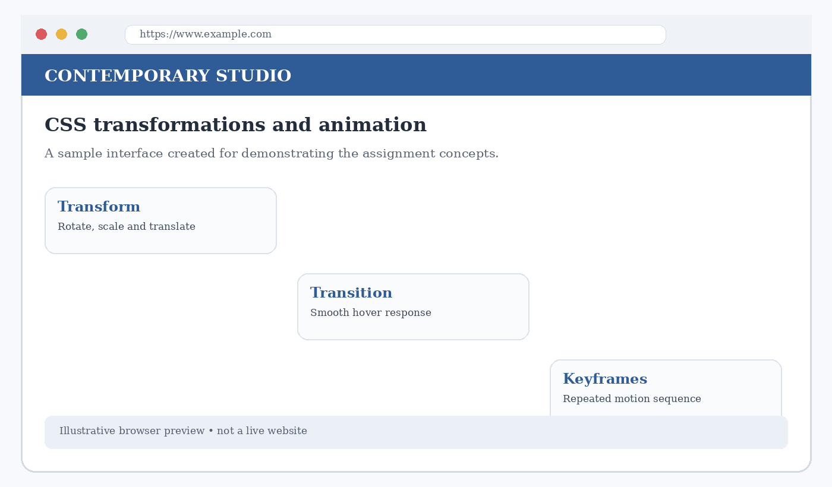
Figure: Illustrative generated visual for the related case study.
Key point: A clear implementation is easier to maintain than unnecessary complexity.

Q5 • Progressive Web Applications

1. Introduction and architecture of PWA
A Progressive Web Application (PWA) is a web application that uses modern browser capabilities to provide an experience similar to an installed application. A PWA is still built using web technologies such as HTML, CSS and JavaScript, but it can offer installability, offline support, responsive behaviour and selected device integrations. The exact features available depend on the browser, operating system, security requirements and permissions granted by the user.
Consider a photography portfolio and booking website that also provides a PWA experience. Visitors can browse service information, view previously cached portfolio content and return to the application from an installed icon. A service worker can manage selected network requests and caching. A web app manifest provides application metadata, such as the name, icons and display mode. Push notifications may be used for booking updates when the user has granted permission.
A PWA architecture typically includes the user interface, web application manifest, service worker, browser storage and web server. The interface is built from HTML, CSS and JavaScript. The manifest describes how the application should appear when installed. The service worker runs separately from the page and can intercept eligible network requests. Cache Storage can store selected resources. The server provides the application files and any dynamic data.
A PWA should be designed progressively. The basic website must remain usable even if a browser does not support installation or a service worker. Additional capabilities should enhance the experience rather than become a requirement for accessing essential information. This principle helps the same website work across a wide range of browsers and devices.
The architecture diagram below summarises the relationship between the interface, manifest, service worker and server. It is a conceptual model; actual applications may also use APIs, databases, authentication services and content delivery networks.
Key point: Website quality depends on structure, usability, accessibility and testing.

2. Web app manifest and installability
A web app manifest is a JSON file that provides information about a web application. Common fields include name, short_name, start_url, display, background_color, theme_color and icons. The name is the full application name, while short_name is a shorter label that may appear below an installed icon. The start_url identifies the page opened when the application launches. The display field can request a mode such as standalone.
Example manifest:
{
"name": "Lumina Photography",
"short_name": "Lumina",
"start_url": "/",
"display": "standalone",
"background_color": "#ffffff",
"theme_color": "#17243a",
"icons": [
{
"src": "/icons/icon-192.png",
"sizes": "192x192",
"type": "image/png"
},
{
"src": "/icons/icon-512.png",
"sizes": "512x512",
"type": "image/png"
}
]
}
The manifest is connected to the HTML document using a link element:
<link rel="manifest" href="/manifest.webmanifest">
The icon files should be available at the specified paths and should have the stated dimensions. The application should use a suitable theme colour that matches its visual identity. The start URL should resolve correctly when the application is launched from its installed icon.
Installability requirements differ between browsers and platforms. Common expectations include serving the application over a secure context, providing a valid manifest and supplying appropriate icons. Some browsers may expose an install option automatically, while others provide installation through a browser menu. Developers should test on the target browsers rather than assuming that the same installation prompt appears everywhere.
The manifest does not contain the application's full functionality. It describes how the application should be presented and launched. Offline behaviour is generally handled by the service worker and caching. Keeping the manifest separate from JavaScript makes the application metadata easy to inspect and update.
Key point: Semantic elements describe meaning; CSS and JavaScript provide presentation and behaviour.

3. Service workers and caching strategies
A service worker is a JavaScript file that the browser can run in the background, separate from the page. It can listen for lifecycle events such as install and activate, and it can handle fetch events for eligible requests. A service worker commonly supports offline experiences by storing selected resources in Cache Storage and deciding whether a request should be served from the cache or network.
A service worker is generally registered by the page using navigator.serviceWorker.register('/service-worker.js'). Registration requires a secure context in normal deployment, with localhost commonly treated as a development exception. During installation, the service worker can pre-cache essential files. During activation, it can remove outdated cache versions. During fetch handling, it can respond with cached or network resources according to the selected strategy.
Common caching strategies include cache first, network first, stale while revalidate and network only. Cache first checks the cache before using the network and is suitable for versioned static assets. Network first tries the network and falls back to the cache, which can suit frequently updated content. Stale while revalidate returns cached content quickly and updates the cache in the background. Network only is suitable for requests that must reach the server.
Example service worker:
const CACHE_NAME = "lumina-v1";
const FILES = ["/", "/index.html", "/styles.css", "/app.js"];
self.addEventListener("install", event => {
event.waitUntil(
caches.open(CACHE_NAME).then(cache =>cache.addAll(FILES))
);
});
self.addEventListener("activate", event => {
event.waitUntil(self.clients.claim());
});
This simplified example pre-caches core files. A production service worker should also manage old cache versions and handle failed network requests carefully.
Caching must be planned to avoid showing outdated information. Static files with versioned names can be cached for longer periods, while booking availability and other frequently changing data should use an appropriate network strategy. Sensitive user data should not be cached casually. Developers must also consider cache storage limits, invalidation and what should happen when a user signs out.
Key point: HTML5 features should be selected according to the needs of users and the website.

4. Push notifications and enhanced experience
Push notifications allow a web application to deliver messages to a user even when the page is not currently open, subject to browser and operating-system support. A typical push workflow involves the application requesting permission, subscribing the browser through the Push API, sending the subscription information to an application server and receiving a push event in the service worker. The service worker can then display a notification using the Notifications API.
Notifications must be permission-based. The application should explain the benefit before asking for permission and should not display a permission prompt immediately without context. For a photography booking service, a useful notification might inform a customer that a booking request has been confirmed or that a consultation is approaching. Promotional messages should be limited and should respect user preferences.
A notification may include a title, body, icon and destination URL. When the user selects it, the service worker can handle the notificationclick event and open the relevant page. The destination should be meaningful and should not expose private information on a shared lock screen. The application server must protect subscription details and validate requests.
Push delivery depends on browser support, permission, network conditions and the push service. It should not be treated as a guaranteed real-time communication channel. Important information should also be available inside the application or through another reliable communication method. Users should be able to control notification preferences and revoke permission through browser settings.
Other PWA capabilities may include responsive layouts, offline access to selected content, background synchronisation where supported, share integration and installation. These capabilities can improve convenience, but the developer should provide fallbacks. A PWA should not assume that every device supports every feature.
Key point: Examples should be tested in browsers and adapted to the actual project.

5. Working principles, testing and conclusion
The working process of a PWA begins when a user visits the website. The browser downloads the HTML, CSS and JavaScript files from the server. The page registers the service worker and links to the manifest. The service worker installs and may cache important resources. When the user revisits the application, the service worker can serve cached files or request updated content from the network. If push notifications are enabled and permission is granted, the application server can send a push message through the browser's push service.
A PWA should be tested in several conditions: first visit with a network connection, repeat visit, offline mode, slow network, cache update, installation and notification permission. Browser developer tools can inspect the manifest, service worker status, cache storage and network requests. Test that the application still provides a useful experience when offline and that dynamic information is clearly identified when it may be outdated.
Security is essential. The application should use HTTPS in production, validate server-side input, protect authentication tokens and avoid storing sensitive information in a cache. Service worker scope should be limited to the intended application path. Push subscription endpoints and application-server credentials must be handled securely. Permission requests should be transparent and user-controlled.
The generated PWA preview illustrates an installable application with offline and engagement features. The accompanying architecture diagram shows the main components. These are explanatory visuals created for the assignment and do not claim that a deployed PWA or push service is running.
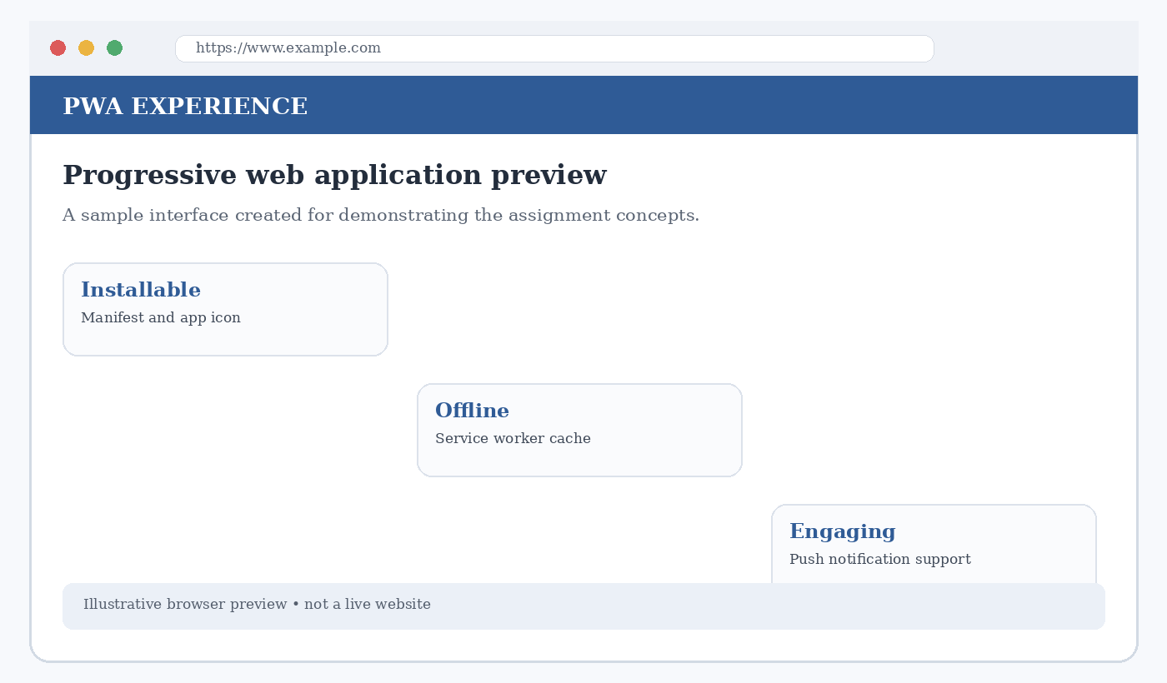
Figure: Illustrative generated visual for the related case study.
Key point: A clear implementation is easier to maintain than unnecessary complexity.

REFERENCES
- WHATWG. HTML Living Standard. https://html.spec.whatwg.org/
- MDN Web Docs. HTML: HyperText Markup Language. https://developer.mozilla.org/en-US/docs/Web/HTML
- MDN Web Docs. CSS: Cascading Style Sheets. https://developer.mozilla.org/en-US/docs/Web/CSS
- MDN Web Docs. CSS cascade, specificity and inheritance. https://developer.mozilla.org/en-US/docs/Web/CSS/CSS_cascade
- MDN Web Docs. CSS transforms, transitions and animations. https://developer.mozilla.org/en-US/docs/Web/CSS/CSS_transforms
- MDN Web Docs. Progressive Web Apps. https://developer.mozilla.org/en-US/docs/Web/Progressive_web_apps
- web.dev. Learn PWA. https://web.dev/learn/pwa/
- Google Developers. Web app manifest. https://developer.mozilla.org/en-US/docs/Web/Manifest
- Google Developers. Service workers and caching concepts. https://developer.mozilla.org/en-US/docs/Web/API/Service_Worker_API
- W3C. Web Content Accessibility Guidelines (WCAG) overview. https://www.w3.org/WAI/standards-guidelines/wcag/

